**Screenshot – Assignment 5 by Venneti Kalyana Chakravarthy**

**Question 1. Write a function to compute 5/0 and use try/except to catch the exceptions**

**Solution:**

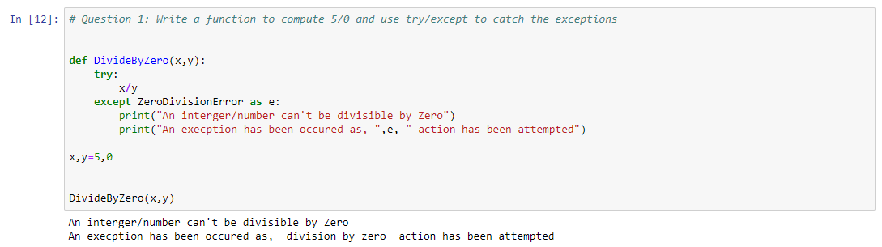

**Question 2:** ​Implement a Python program to generate all sentences where subject is in ["Americans", "Indians"] and verb is in ["Play", "watch"] and the object is in ["Baseball","cricket"].  
Hint: Subject,Verb and Object should be declared in the program as shown below.  
subjects=["Americans ","Indians"]

verbs=["play","watch"]  
objects=["Baseball","Cricket"]  
**Output should come as below:**

Americans play Baseball.  
Americans play Cricket.  
Americans watch Baseball.  
Americans watch Cricket.  
Indians play Baseball.  
Indians play Cricket.  
Indians watch Baseball.  
Indians watch Cricket.

**Solution:**

